15. Sexual Reproduction and Development in Animals I *(RHM: Chapters 49, 50)*

______________________________________________________________________________

I. Introduction *(1145-1147)*

A. Asexual vs. Sexual Reproduction

B. Developmental Biology and Embryology

C. Early Stages of the Life Cycle

1. Gametogenesis

2. Fertilization

3. Cleavage

4. Gastrulation

5. Morphogenesis and organogenesis

D. Principles of Development

II. Gametogenesis *(1147-1148)*

A. Spermatogenesis

1. Origin of sperm

2. Structure of sperm

B. Oogenesis

1. Origin of ova

2. Structure of ova

3. Variability among species and habitats

III. Fertilization *(1148-1151)*

A. Behaviors that Promote Contact of Gametes

B. Fertilization

1. Receptor substances

2. Sperm activation / acrosome reaction

3. Cortical reaction of the egg

4. Blocks to polyspermy

5. Egg activation

6. Fusion of nuclei

IV. Cleavage *(1167-1173)*

A. Cellular Events

1. Genome replicaton

2. Membrane production

3. Production of blastula

B. Patterns of Cleavage

1. Radial cleavage in Deuterostomes

2. Spiral cleavage in Protostomes

15-1

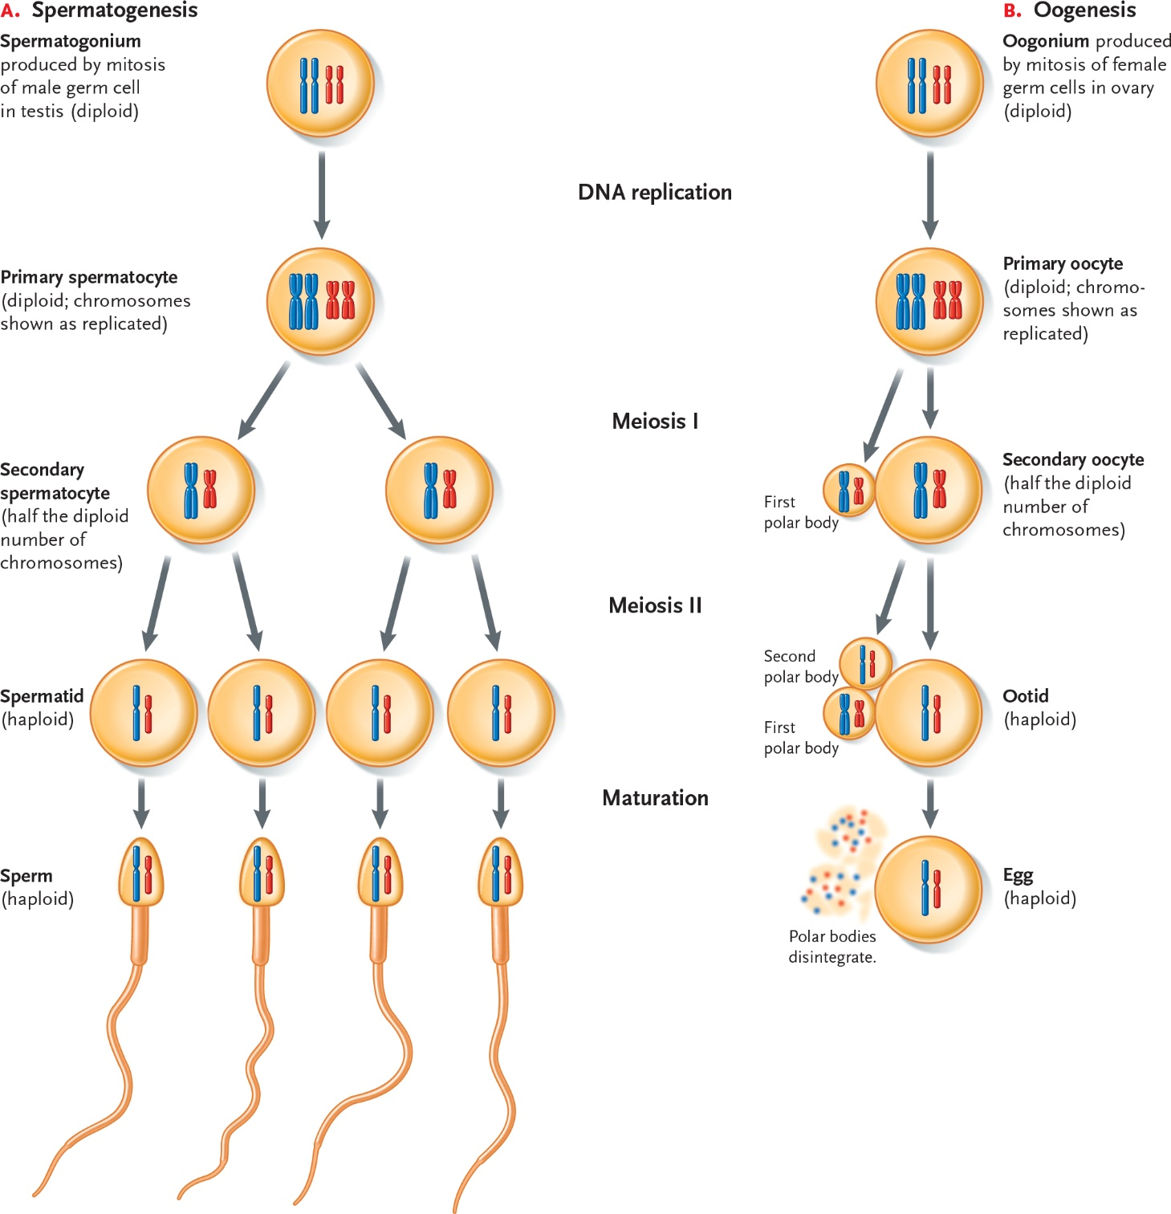

15-2

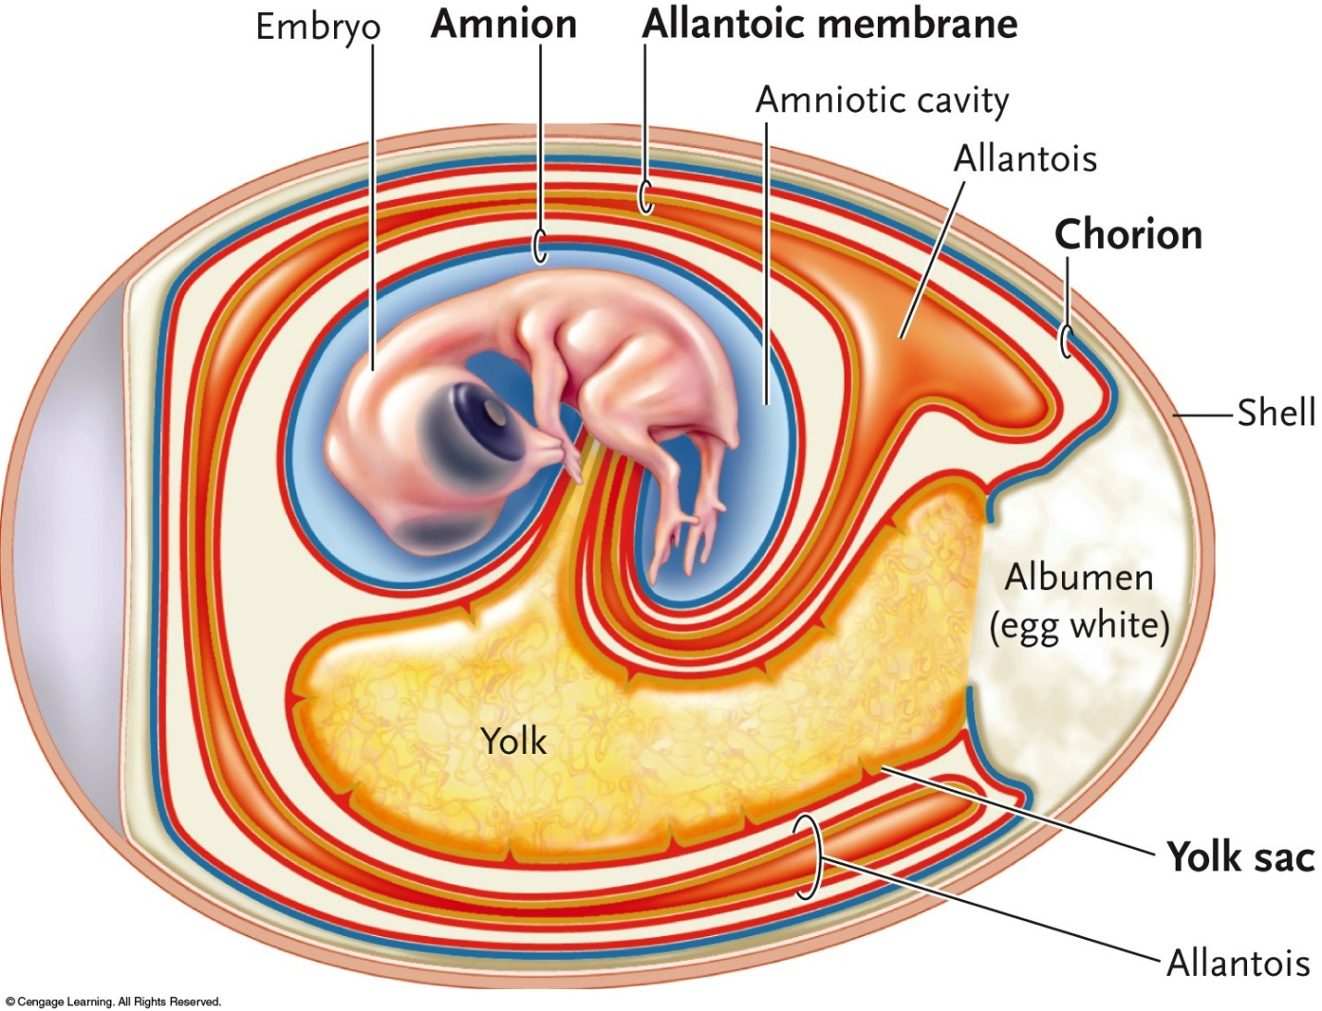

15-3

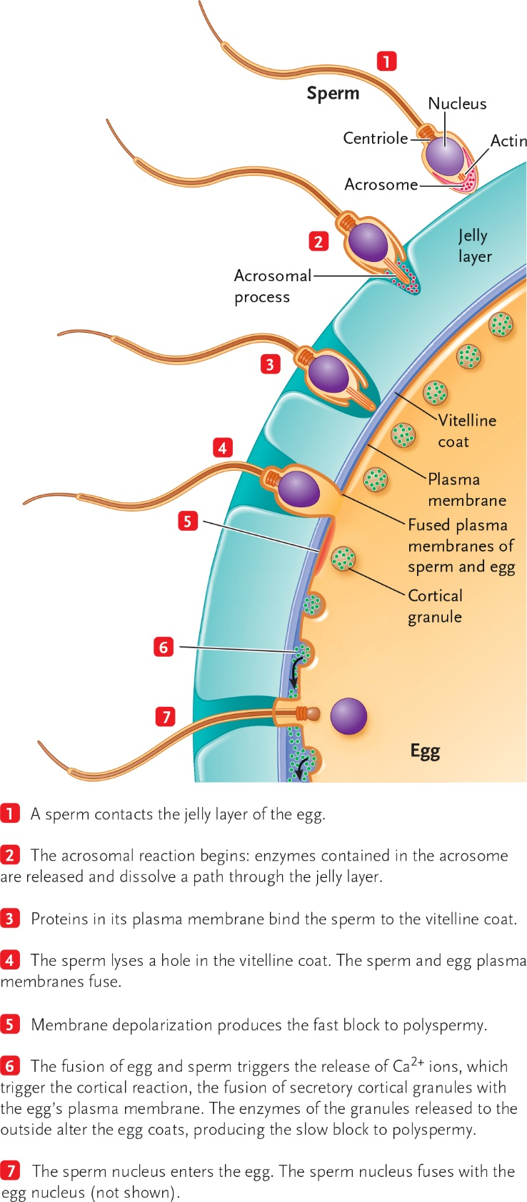

15-4

